Media Kit

Company Overview
Ms. Debra Ann Matthews recognized the need to assist people with delivering positive career related attributes a few years ago as she began teaching English, Public Speaking, Technical Report Writing and Business Communication Classes at Embry Riddle Aeronautical University at Fort Campbell, KY Military Installation in 2006. Her previous experiences teaching low income parents career skills in President Clinton’s AmeriCorps Program in 1994 (Knoxville, TN) began her journey in the area of sharing information about what’s possible for entry-level job seekers. Ms. Matthews’ additional experiences include working with an international singing group called Up With People. She developed her love for sharing knowledge about how anyone can dream and obtain their career of choice to young people as the Occupational Employment Program Specialist with the Memphis Job Corps Center. Traveling to London and working with the Royal Philharmonic Orchestra in the Marketing Department as a part of her master’s level training at Austin Peay State University, she began to put the pieces of the career puzzle together as she witnessed how Europeans are educated and trained for their professions. Since that time, she has continued her work with Job Corps in Middle Tennessee assisting youth ages 16 to 24 who graduate and those who do not complete their training with career services. She’s most excited about extending her passion for helping motivated job seekers showcase their skills, potential and demonstrated success to the nation’s top organizations who eagerly await their presence! As the Best Master Degree Resume Writer This Side of the Mississippi, Ms. Matthews recently obtained her Certification as a Job and Career Development/Transition Coach and offers her clients Resume Services, Job Search, Resume Distribution Services and Career Coaching. She also serves as a public speaker on various topics of interests to business networking groups, high school organizations, non-profits, churches and other interested person. As she likes to say, “Can’t Say It? Let Me Write It For You!

Products & Services
RUBY PACKAGE Your Investment at $897.00 includes: A Professional, Job-Winning Resume, Convincing Cover-letter, Bio, Social Media Package (QR Codes, LinkedIn Profile Set-up or revision, 1 page website presence), Assessment, Resume Distribution Package and Basic Job Reference Check.

SAPPHIRE PACKAGE Your investment starting at $597.00 includes a Professional Resume (Word, PDF and ASCII text formats); Client focused cover letter, Resume Distribution Service (Recruiter database of up to 15,800 job openings. Each client receives a listing of recruiters who serve clients domestically and internationally for follow-up).

DELUXE PACKAGE Your investment at $497.00 includes a Professional Resume, Convincing Skills Sets Cover Letter, Reference Sheet and DISC Assessment. Bonus: Free Interview Tips/101 Ways to Skyrocket Your Career e-book Your Career Is Our Job.

MILITARY EXPERT PACKAGE Your investment starting at $377.00 includes Professional Consultation and initial Job Search Leads and A Professional Resume.

EXPERT PACKAGE Your investment starting at $347.00 includes A Professional Resume (Clients with professional experiences, M.A., MBA, salary over $40,000).

JASPER PACKAGE at $297.00 includes a Professional Career Consultation, a one page Bio, Career Assessment, DISC Assessment Profile.

ONYX PACKAGE at $157.00 includes one page Resume (Clients with entry-
level, customer service including high school graduates, displaced workers, Welfare to Work Graduates).

Press Releases
The Bridge to Success…  15 Years of Educating and Connecting  Career Services Professionals |  | THe NRWA 15th Annual Conference  September 19-22, 2012  Charleston, South Carolina
For Immediate Release September 25, 2012

For more information, contact:
Debra Ann Matthews, Professional Résumé Writer
Post Office Box 156, Clarksville, Tennessee 37041
letmewriteitforyou@gmail.com
http://jobwinningresumes.net

Résumé Writer in Clarksville Gains Valuable Information on Techniques to Ensure Job Search Client Success
Debra Ann Matthews http://jobwinningresumes.net attended the National Résumé Writers’ Conference to learn leading-edge methods to better position job seekers for gaining a competitive advantage in today’s tumultuous employment environment.
Nashville, Tennessee – September 25, 2012 – Positioning job search clients for success in the employment marker requires commitment to on-going career industry-related training.
Debra Ann Matthews of Let Me Write IT For You from Clarksville, Tennessee, received advanced training and learned about the latest trends, issues and technologies impacting the careers industry from leading career industry presenters at the 2012 National Résumé Writers’ Annual Conference. The conference, which is held annually, caters to professional résumé writers, career coaches, and educational institution placement professionals.
Debra Ann Matthews garnered expert knowledge in:
- Effective job seeker branding techniques to provide added value in résumé and career-related documents.
- How to design and compose résumés for a variety of individuals, including career-change, executive, 20-something, and military-transition clients.
- Techniques to prepare clients to answer difficult interview questions.
- The latest trends in social medial and its impact on job seekers.
“Keeping current with trends in the career services industry helps me to better assist my clients with their job search,” stated Debra Ann Matthews. “Clients benefit from my continued training efforts on cutting-edge techniques in the résumé writing and job search process because I can provide them with exceptional career documents and information that could shorten their job search and ensure their success.”
Let Me Write IT For YOU has been serving the résumé writing industry for more than five year. Matthews specializes in job-winning résumés for motivated clients, willing to actively give their 100% investment to garner exceptional job opportunities. For more information or to contact Debra Ann Matthews, Professional Résumé Writer of Let ME Write IT For YOU visit her website @ http://jobwinningresumes.net, email her @ letmewriteitforyou@gmail.com or call 931-269-WR1T (9718).
###

Personal Fact Sheet

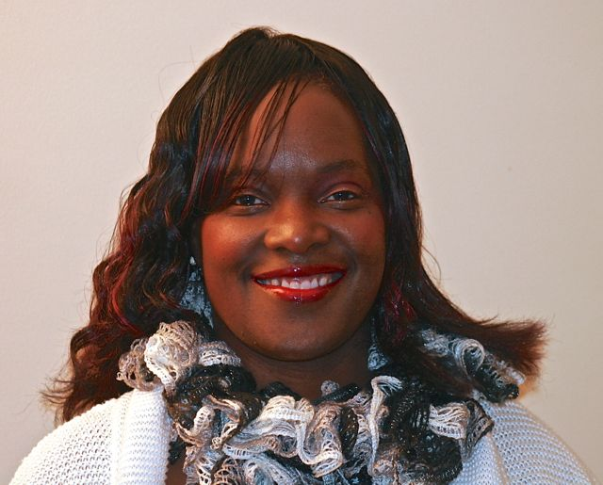

List of Suggested Questions
Question 1. What should people do in the age of recession as it relates their job search?
Question 2. How can college students prepare to obtain their first job out of college?
Question 3. Should military veterans get assistance locating their first job after leaving the military with a career resource professional?
Question 4. Are there some bits and pieces of advice that you can give to people who seek jobs who are felons and/or ex-inmates?
Question 5. How can stay at home mom's and dad's jump back in the workforce?
Question 6. Are there advantages for business owners to have a resume? What do they do once they get them?
Question 7. What's wrong with my resume?
Question 8. I don't know what I'm doing, please help.
Question 9. I am not getting paid what I am worth, how can your company assist me in this area?
Question 10. And I am accustomed to making top dollar, but now I have been downsized. Can you help me? How ?

Links to media mentions and/or Press Appearance

What Not to Do in Startup Job Interviews - Part 4 http://www.nbcchicago.com/blogs/inc-well/What-Not-to-Do-in-Startup-Job-Interviews---Part-4-215525761.html via @incdotwell (Quote included by Debra Ann Matthews)
Debra Ann Matthews & Tina Nicolai - 2012: http://youtu.be/n2FqUC8lJKw via @youtube
The Value of Career Directors with Debra Ann Matthews - 2012: http://youtu.be/e_NVWM2yV_8 via @youtube
CSBNA - With Debra Ann Matthews of Let Me Write It For You 4/3/12: http://youtu.be/jpLrD1KjPSg via @youtube
Examiner/com http://www.examiner.com/career-advice-in-nashville/debra-ann-matthews
Local Job Network http://www.localjobnetwork.com/articles/author/Debra-Ann-Matthews/622
Ezine Articles http://ezinearticles.com/?expert=DebraAnn_Matthews
If a career change is on your list of goals for 2013, here's some expert advice to help you make it happen. (Thank you for your contributions to the article Laurie Battaglia, Caroline Adams Millerand Debra Ann Matthews.) http://www.fabjob.com/calgarysun-2013-01-06.html
6 Bits of Career Advice for Felons and People With Criminal Records Seeking their next great job: http://bit.ly/11u5i4b
What Job Interview Questions Keep You Up At Night? | JenningsWire http://bit.ly/YYmnsb
Volunteering enhances careers. Look ! Beef Up Your Resume http://bit.ly/10tw3sS #Please Retweet
Career Development Carnival http://ow.ly/jjibU Featuring: @Letmewriteit4u @VASegovia @Pasmuz
PTSD suicide more deadly to American Soldiers than combat! | The Guardian Express http://bit.ly/12gis6R
5 Reminders 2 Write Effective Job Descriptors for Job-Winning Resumes at careerthoughtleaders.com: http://bit.ly/18SuzMl
The Perfect Retail Banking Resume - Finance and Accounting Jobs News and Advice http://www.fins.com/Finance/Articles/SBB0001424052970204136404577211291090075100/The-Perfect-Retail-Banking-Resume
Job Winning Resume Blog http://wp.me/2QU2j

